JDBC

JDBC provides us certain APIs (Classes and Interfaces) using those APIs we can connect the Java program to any database to perform CRUD (Create, Retrieve, Update and Delete) operation.

Java Program <<>> JDBC APIs <<>> Driver <<>> Data Source

We can see mentioning data-source instead of Database because we can retrieve data from different-different sources like Files, Excel-Sheets, Hudoop and including Database (DBMS or RDBMS).

What is driver here?
Database is used to store data not only because it can store information in a particular order but also cause of security reason. Database is the most secure place to store data.

Cause of security reason, Database vendors provided APIs that were able to connect programing language with their database and perform operations. The prime reason to create this Vendor Specific API was hiding the internal working/architecture of database management system. So the programing languages will communicate to database via vendor specific APIs and they won’t have direct access.

But It has drawback, Suppose a business started and they had only 1000 employees so obvious they won’t use Oracle DB for this, the MySQL is the best option for them. But in future if their business increases and they wanted more space to store data, they have to change the database.

Once an applications is developed with one DBMS, it was very hard to change the database. Because developers had used that API program in so many places, that was very-very tough to replace with new API program. So in this case they had to create new software version every time they wanted to change the database, it were costing of both time and money.

So from here need to came to create a general kind of API that will change the database type with little programing changes. Microsoft (Billu) was the first one who created this kind of API named ODBC (Open Database Connectivity).

ODBC Driver
Now the point is how ODBC is doing this, does he getting the architecture from database vendors? No actually it has made common functions inside ODBC driver for all languages and on the basis of database information it hits that database vendor specific API.

Implementation
Of ODBC
Implementation
Of ODBC
Any Programing
Language
ODBC API
Implementation
Of ODBC
Oracle
MySQL
Other Database
Implementation
Of ODBC
Implementation
Of ODBC

JDBC

Java has also made his own driver named JDBC. JDBC driver is nothing, these are just a classes which are implementing a JDBC interfaces and generally made by database vendors.

Any Programing
Language
JDBC API
Implementation
Of ODBC
Oracle
MySQL
Other Database
Implementation
Of ODBC
Implementation
Of ODBC

There are four types of drivers Type1, Type2. Type3 Type 4.

Type1: This driver was made by Sun Micro System. It has problem that Java technology has to depend on Microsoft. Also It was required to buy license if the program run on other OS except Windows.

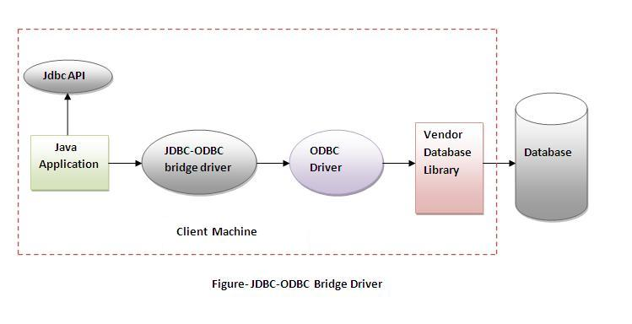

Type 2 driver: Made By SunMicro System. In this case they had to make native driver for every vendor.

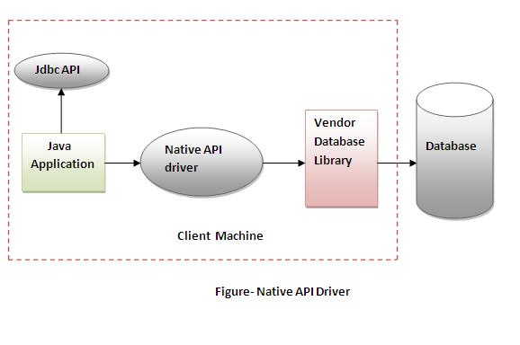

Type 3: Made By SunMicro System. They made a server and put type driver (all vendor specific API) in that. On the basis of database requirement it hits that database. But It was long process to communicate with the DBMS.
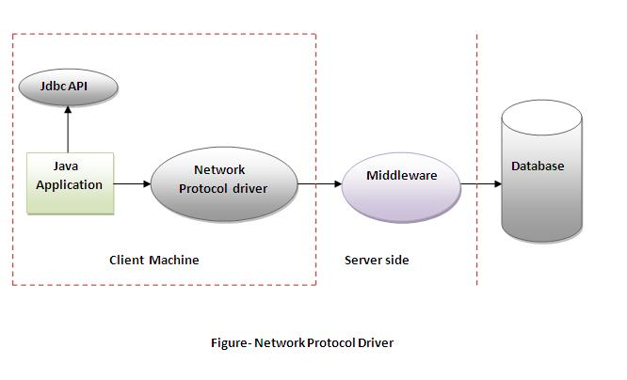
Type 4: Also known as thin driver. Made by database vendors.

